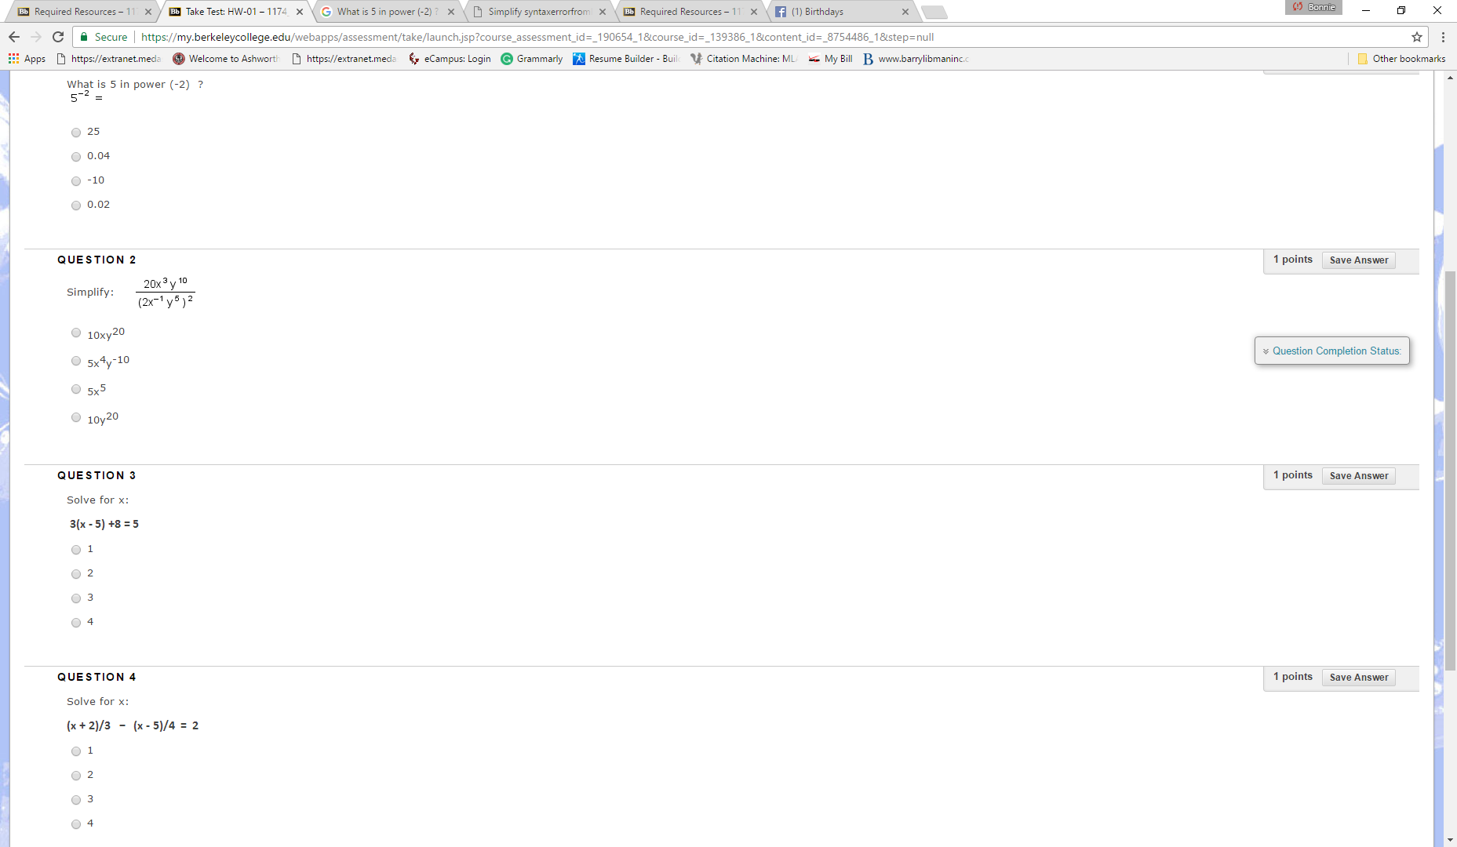

QUESTION 5
- Solve for y:
2x + 5y = 10
y = 10
y = 2x - 5
y = 2 - 0.4x
y = (1 + 2x)/5

